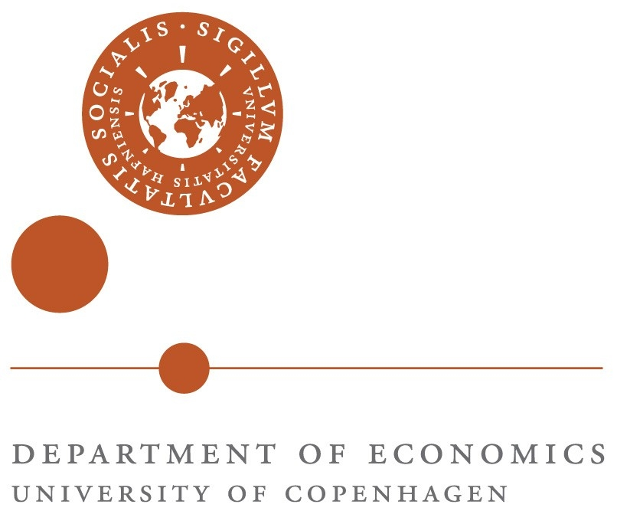

Research Workshop: Stabilization Policies
Copenhagen, 17-18 June 2011
Program

Friday morning, 17 June
Conference Venue: CSS 1.1.18
8.30-9.00 Registration and Coffee

Session 1: Keynote Lectures (overlap with EPRN policy conference)
9.00-10.00: Roel Beetsma (Amsterdam School of Economics): “Planning, Implementation and Revision of Budgets of EU Countries: the Role of Economic, Political and Institutional Factors”
10.00-11.00: Christopher Carroll (Johns Hopkins): “Bang for the Stimulus Buck“
11.00-12.00: Luigi Pistaferri (Stanford): “Empirical challenges in understanding consumption and labor supply responses to stabilization policies”
12.30-13.30 Lunch

Friday afternoon, 17 June
Conference Venue: CSS 26.2.20

Session 2: (chair: Claus Thustrup Kreiner)
13.30-14.30: Camille Landais (Stanford): “Optimal Unemployment Insurance over the Business Cycle”
14.30-15.30: Itay Saporta (Standford): “Consumption Smoothing and Family Labor Supply”
15.30-15.45: Break
15.45-16-45: Søren Leth-Petersen (Copenhagen) /Claus Thustrup Kreiner (Copenhagen): “The consumption and savings effects of unexpectedly getting access to (compulsory) pension savings”

(18.30 Dinner)

Saturday morning, 18 June
Conference Venue: CSS 26.2.20

Session 3: (chair: Søren Leth-Petersen)
9.00-10.00: Mette Ejrnæs (Copenhagen) /Martin Browning (Oxford): Consumption and income: An integrated approach
10.00-11.00: Jiri Slacalek (Johns Hopkins): “Digestible Microfoundations: Buffer Stock Saving in a Krusell-Smith World”
11.00-11.15: Break
11.15-12.15: Asger Lau Andersen (Copenhagen and The Danish National Bank): “Late Budgets”

Lunch

Participants
Asger Lau Andersen [asa@nationalbanken.dk]
Roel Beetsma [R.M.W.J.Beetsma@uva.nl]
Martin Browning [martin.browning@economics.ox.ac.uk]
Chris Carroll [carrollcdc@me.com] or [ccarroll@jhu.edu]
Mette Ejrnæs [mette.ejrnes@econ.ku.dk]
Stefan Hochguertel , VU University Amsterdam [s.hochguertel@vu.nl] or [s.hochguertel @gmail.com]
Claus Thustrup Kreiner [ctk@econ.ku.dk]
Camille Gregoire Alexis Landais [landais@stanford.edu]
Søren Leth-Petersen [Soren.Leth-Petersen@econ.ku.dk]
Itay Saporta (Standford): [isaporta@stanford.edu]
Jiri Slacalek (Johns Hopkins) [jirka@jhu.edu] or [jiri.slacalek@gmail.com]

Sponsors
The workshop is sponsored by The Danish Microeconometric Network, The Economic Policy Research Network (EPRN) and the EPRU/WEST research unit.

